1) Handling Missing Values:
• Check for missing values in the 'Price' column. How would you handle products with missing price information?
- First data is imported through get data option from data tab and select transform data.
- Remove unnecessary or blank columns and rows using remove columns and remove blank rows in home tab in power query editor.
- Then in price column null value is replaced with 0 to calculate median to replace null values.
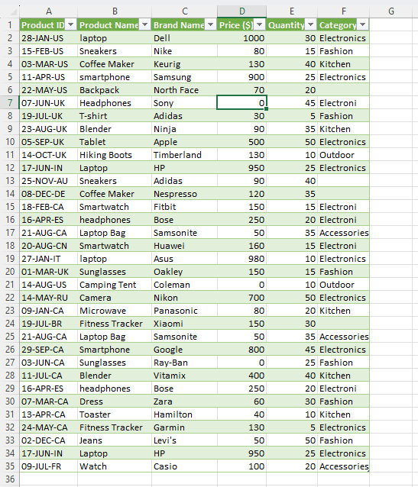
- After replacing with 0, median is calculated and data is loaded into excel.
Dataset (2)
130

- The null values are then replaced in excel by using find and replace with median calculated in power query editor.
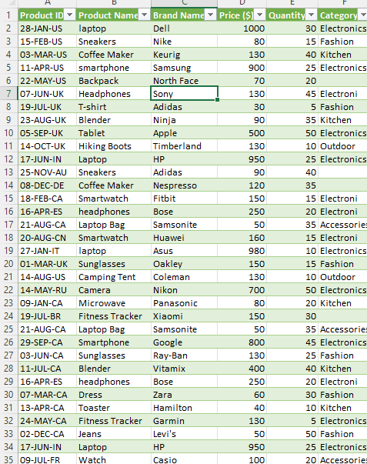

• If there are products with missing categories, propose a strategy to impute or deal with these missing values effectively.
- If there are products with missing categories, then the missed valued are to be calculated by using product name and brand name logically.
- We can also create pre defined rules that map keywords in product names to categories.
- If no necessary information is provided, then it is identified as “unknown”.
- If similar product exists, then it is determined by taking into account most frequently occurring category for the product type.

2) Correcting Inconsistent Data:
• Identify any inconsistent text formats present in the "Product Name" column.
• Identify any typos present in the "Category" column.
• Use the find and replace function to standardize the text formats in the "Product Name" column and fix any typos or misspellings in the "Category" column.
- Identified inconsistent text formats in product name column and changed them by selecting product name column transform Format Capitalize each word.
- In the similar way typos are corrected in category column by selecting the category column replace values Electroni Electronics in advance options match entire cell contents ok.
- Identify the categories by the product name with the given specifications by using conditional column.
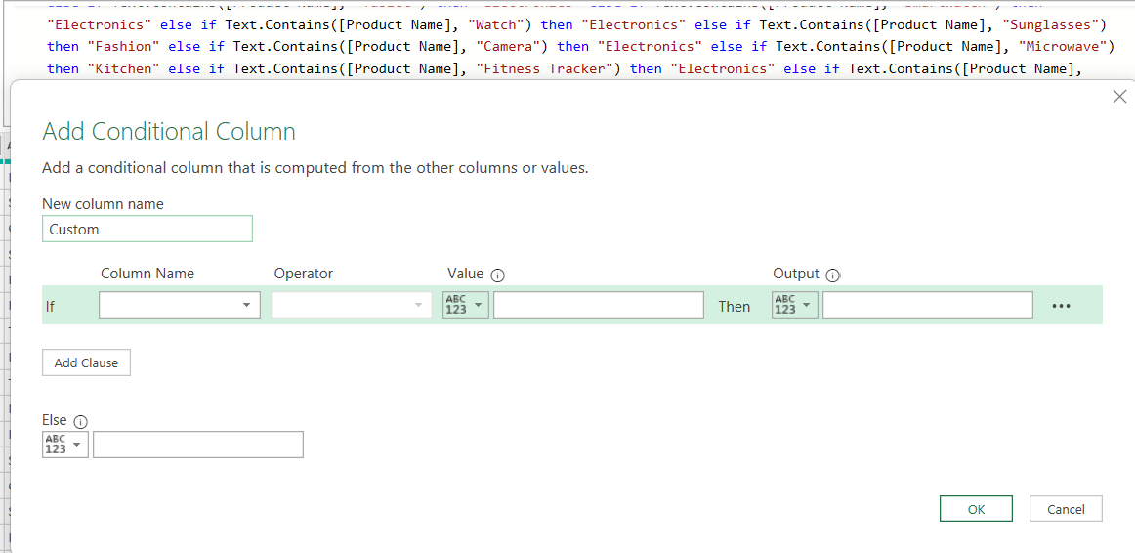

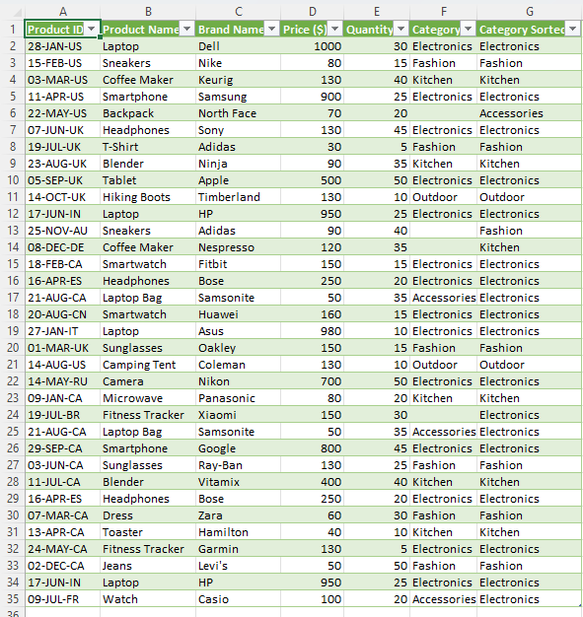

3) Removing Duplicates:
• Identify any duplicate rows within the dataset based on the entirety of each row, and remove them if any.
The duplicate rows are deleted by selecting the entire table and selecting remove rows and remove duplicate rows.
Product ID |  | Product Name | Brand Name | Price ($) | Quantity | Category Sorted
28-JAN-US |  | Laptop | Dell | 1000 | 30 | Electronics
15-FEB-US |  | Sneakers | Nike | 80 | 15 | Fashion
03-MAR-US |  | Coffee Maker | Keurig | 130 | 40 | Kitchen
11-APR-US |  | Smartphone | Samsung | 900 | 25 | Electronics
22-MAY-US |  | Backpack | North Face | 70 | 20 | Accessories
07-JUN-UK |  | Headphones | Sony | 130 | 45 | Electronics
19-JUL-UK |  | T-Shirt | Adidas | 30 | 5 | Fashion
23-AUG-UK |  | Blender | Ninja | 90 | 35 | Kitchen
05-SEP-UK |  | Tablet | Apple | 500 | 50 | Electronics
14-OCT-UK |  | Hiking Boots | Timberland | 130 | 10 | Outdoor
17-JUN-IN |  | Laptop | HP | 950 | 25 | Electronics
25-NOV-AU |  | Sneakers | Adidas | 90 | 40 | Fashion
08-DEC-DE |  | Coffee Maker | Nespresso | 120 | 35 | Kitchen
18-FEB-CA |  | Smartwatch | Fitbit | 150 | 15 | Electronics
16-APR-ES |  | Headphones | Bose | 250 | 20 | Electronics
21-AUG-CA |  | Laptop Bag | Samsonite | 50 | 35 | Electronics
20-AUG-CN |  | Smartwatch | Huawei | 160 | 15 | Electronics
27-JAN-IT |  | Laptop | Asus | 980 | 10 | Electronics
01-MAR-UK |  | Sunglasses | Oakley | 150 | 15 | Fashion
14-AUG-US |  | Camping Tent | Coleman | 130 | 10 | Outdoor
14-MAY-RU |  | Camera | Nikon | 700 | 50 | Electronics
09-JAN-CA |  | Microwave | Panasonic | 80 | 20 | Kitchen
19-JUL-BR |  | Fitness Tracker | Xiaomi | 150 | 30 | Electronics
29-SEP-CA |  | Smartphone | Google | 800 | 45 | Electronics
03-JUN-CA |  | Sunglasses | Ray-Ban | 130 | 25 | Fashion
11-JUL-CA |  | Blender | Vitamix | 400 | 40 | Kitchen
07-MAR-CA |  | Dress | Zara | 60 | 30 | Fashion
13-APR-CA |  | Toaster | Hamilton | 40 | 10 | Kitchen
24-MAY-CA |  | Fitness Tracker | Garmin | 130 | 5 | Electronics
02-DEC-CA |  | Jeans | Levi's | 50 | 50 | Fashion
09-JUL-FR |  | Watch | Casio | 100 | 20 | Electronics

4) Splitting and Merging Data:
• Split the "Product ID" column into two separate columns for " Manufacturing Date" and "Country Code". Remove unnecessary characters, if any.
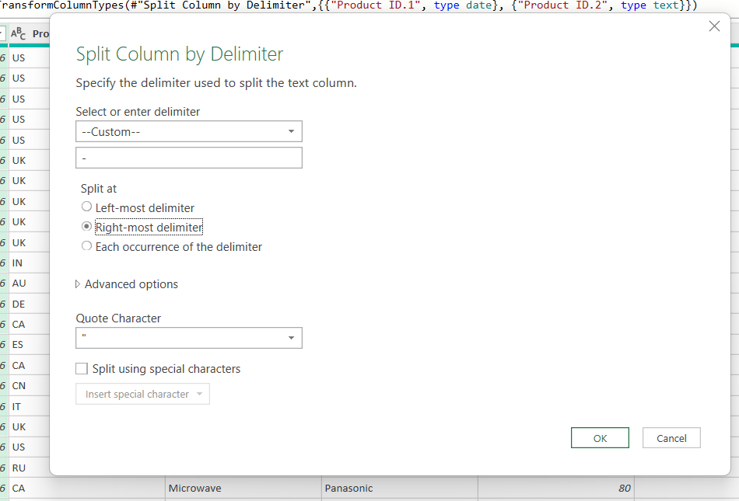
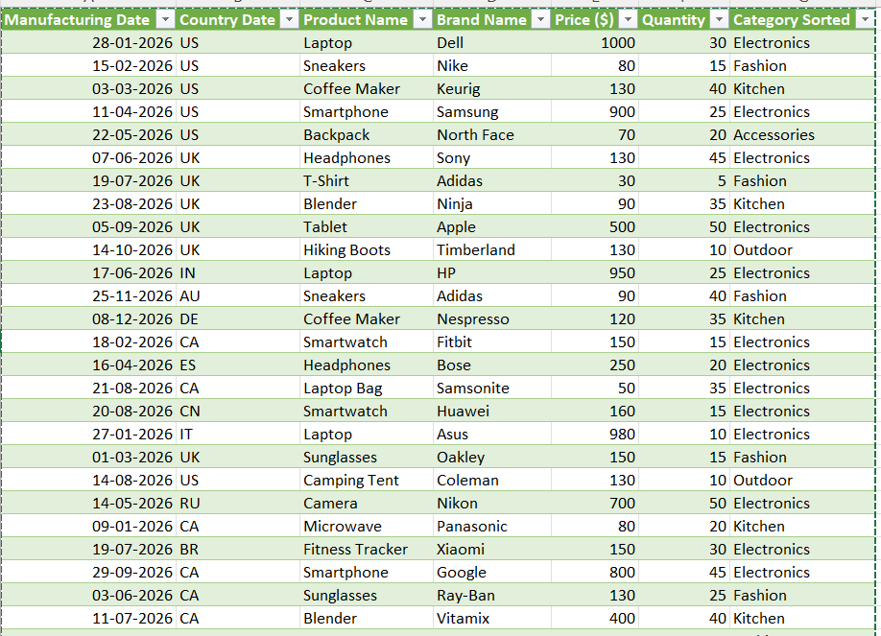
• Merge the "Brand Name" and "Product Name" columns into one column named "Product Brand".

Select the brand name and product name column and select add column---merge columns---seperator space----new column name---ok
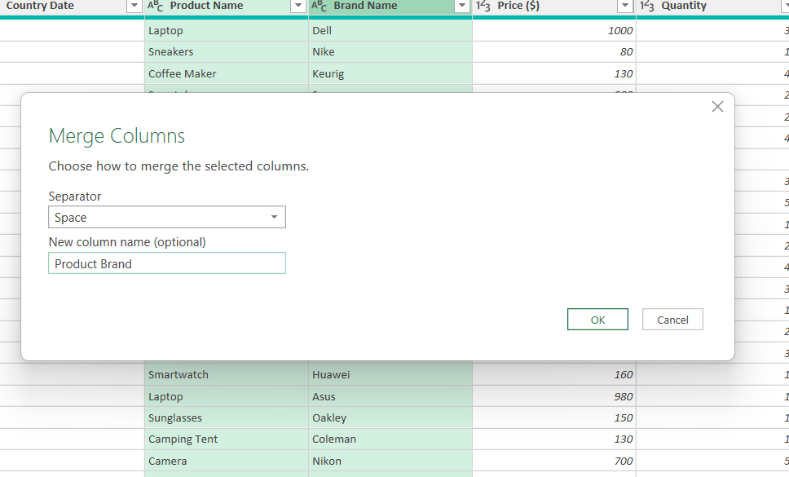
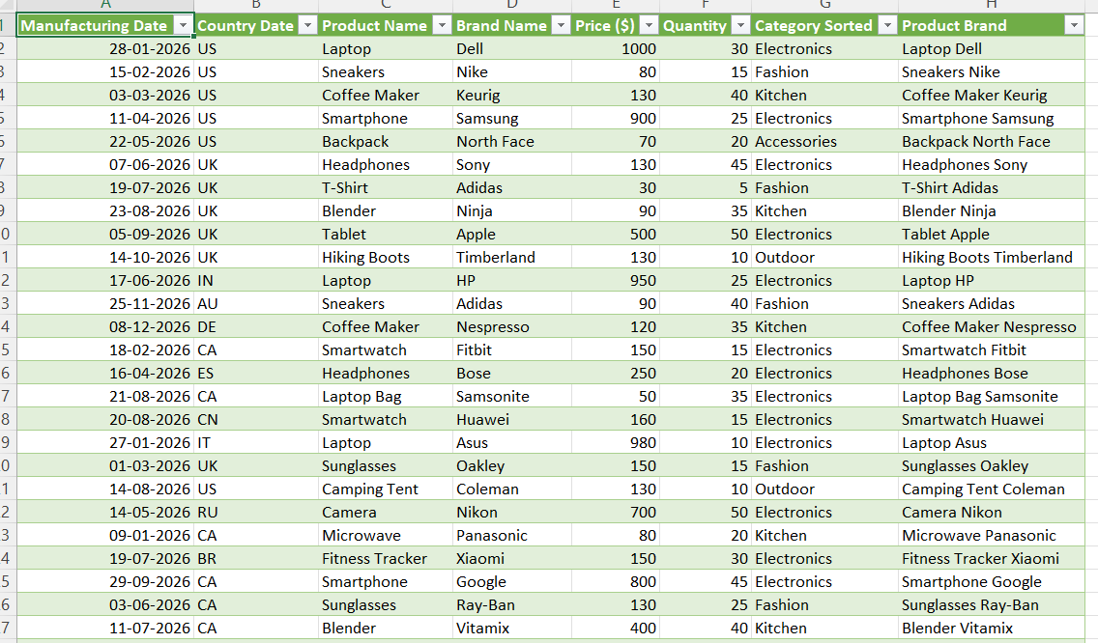

5) Number Formatting:
• Format the data type of the "Price" column to currency format.
• Format the "Manufacturing Date" column to display dates in the "DD-MM-YYYY " format.
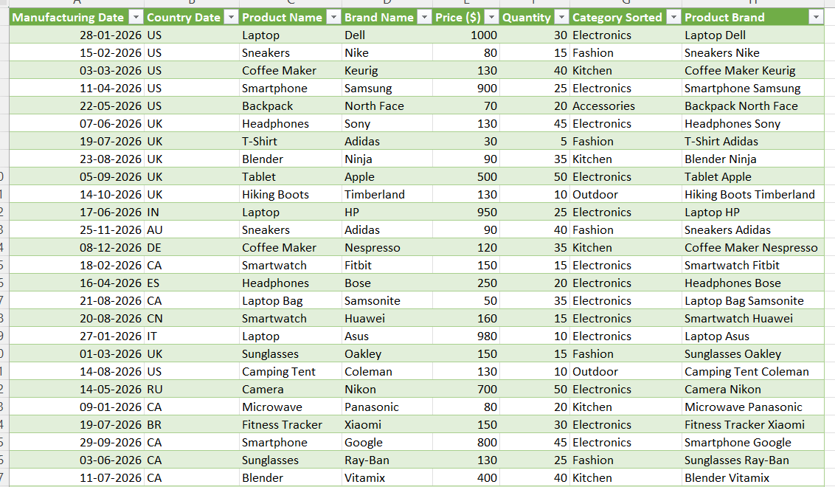

6) Conditional Formatting:
• Apply data bar or color scales conditional formatting in the "Price" column.
• Create a custom rule for conditional formatting in the "Category" column to highlight cells where the category is "Electronics."

